# QuPath SAM Walkthrough (7/8/2025) AI bootcamp team 3

(Larissa Langhi Prata, Yan Ou, Jing Cui, Atieh Abedin, Jack Wei –

Coaches: Joshua Levi and Jose Cortina)

1. **Open Qupath, Install and Activate SAM** (follow the installation instructions in [GitHub - ksugar/samapi: Segment Anything Model API](https://github.com/ksugar/samapi)
   * Ensure SAM is installed and activated. You can verify this by navigating to Extensions > Manage Extensions and searching for SAM in the list.
2. **Open Qupath. Open Your Project**:
   * Project > Open Project.
3. **Add Image to Project**:
   * Project > Add Images.
   * Find your image file, select it, and click Open.
4. **Save Project**:
   * Once your image is added, save the project by going to Project > Save Project.
5. **Save Image**:
   * To save any changes or annotations made to the image, go to File > Save or File > Export Image.
   * This will ensure your image is saved correctly within the project, and any modifications are preserved.
6. **Run SAM**:
   * Open Anaconda and run:

*conda activate samapi*

* + IF already installed, run a server:

*export PYTORCH_ENABLE_MPS_FALLBACK=1 # Required for running on Apple silicon*

*uvicorn samapi.main:app --workers 2*

* + On QuPath, Go to Extensions > Simple Analysis Module (SAM).

1. **Annotating on SAM**
   * on SAM window> PROMPT tab > multimask best quality, select rectangle tool or points tool. For points tool, make sure you select background or foreground classes on the annotations tab or preselect them at SAM window.
   * Select all annotations in the annotations window on Qupath before running the selected!

Example of point tool (gray – background, yellow – foreground or cells)

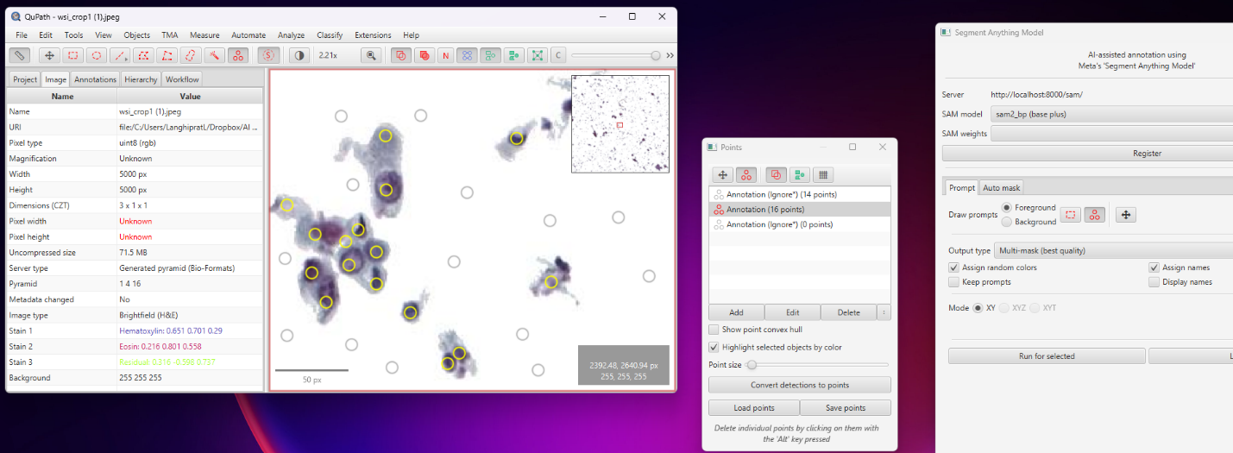

Example of rectangle tool (select entire cell, nucleus and all – better for clusters segmentation)

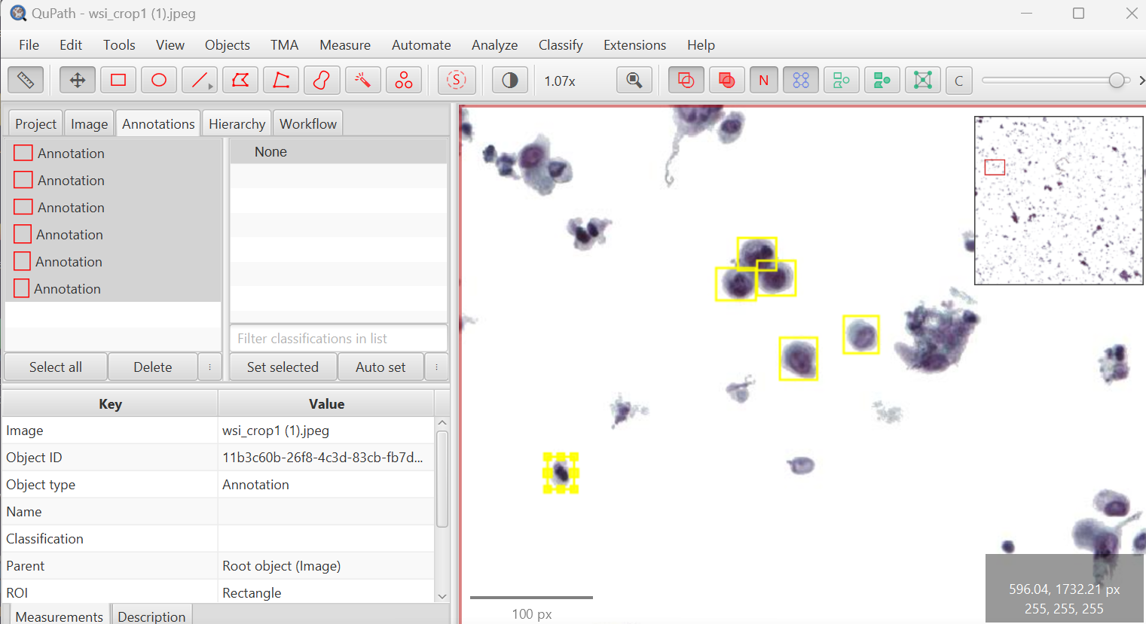

Run for selected:

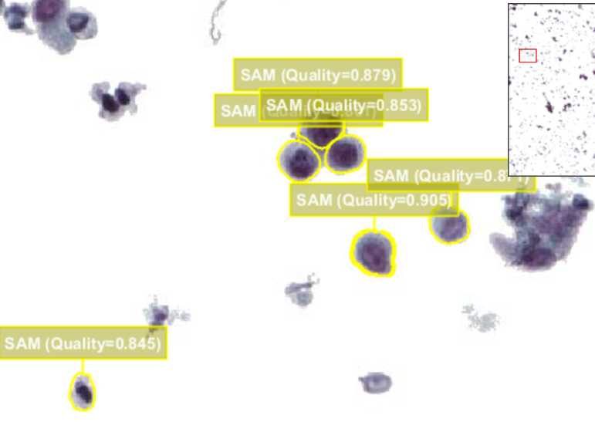

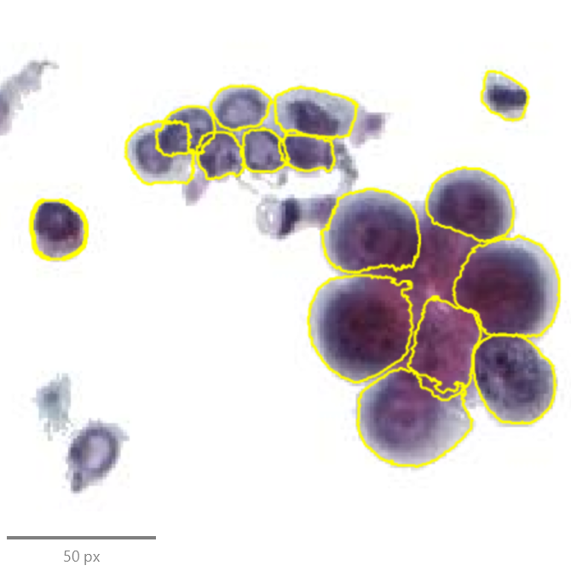To segment large clusters, more training is needed. Keep drawing rectangles and using the successes as new annotations for new training:

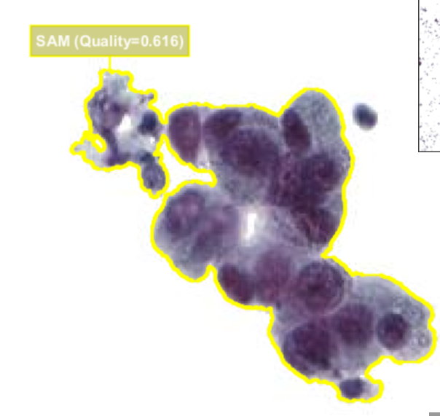

* + Use Live mode and see the cells being correctly segmented as you go (video)
  + In the end, erase all square or point annotations to export the masks.

1. **Export annotations in File>export objects as GeoJSON**
2. **Use a python script to convert annotation into a mask (To test) (qupath help link:** [Exporting annotations — QuPath 0.6.0 documentation](https://qupath.readthedocs.io/en/latest/docs/advanced/exporting_annotations.html#exporting-annotations) )

*import cv2*

*import json*

*import numpy as np*

*# Load the GeoJSON file*

*with open('annotations.geojson', 'r') as f:*

*data = json.load(f)*

*# Create a blank mask*

*mask = np.zeros((image_height, image_width), dtype=np.uint8)*

*# Draw each annotation as a mask*

*for feature in data['features']:*

*coordinates = feature['geometry']['coordinates'][0]*

*points = np.array(coordinates, dtype=np.int32)*

*cv2.fillPoly(mask, [points], 255)*

*# Save the mask*

*cv2.imwrite('cell_mask.png', mask)*